11th Paul Walden Symposium on Organic Chemistry
September 19-20, 2019; Rīga, Elizabetes iela 73
Radisson Blu Elizabete Hotel

Program

Thursday, September 19

9.00- 9.10 Professor Edgars Sūna (Chairman of the Scientific Board, Latvian Institute of Organic Synthesis)

Welcoming remarks

9.10 - 9.30 Presentation of the Paul Walden medal to Professor Aigars Jirgensons (Latvian Institute of Organic Synthesis) by Māris Turks, Dean of the Faculty of Materials Science and Applied Chemistry (Riga Technical University)

9.30 -10.20 Professor Aigars Jirgensons (LIOS, Riga, Latvia)
“Carbocation chemistry: a rich source of new synthetic methods”
10.20-11.10 Professor Benjamin List (Max-Planck-Institut fűr Kohlenforschung, Műlheim an den Ruhr, Germany)
„Very strong and confined acids enable a general approach to asymmetric Lewis acid catalysis”
11.10-11.40 Coffee break
11.40-12.40 Professor Jerome Waser (Ecole polytechnique fédérale de Lausanne, Institut des sciences et ingénierie chimiques, Lausanne, Switzerland)
„Hypervalent iodine reagents: a wonderful toolbox for organic synthesis”
12.40-13.00 Symposium group photo
13.00-14.30 Lunch
14.30-15.30 Professor Burkhard Kőnig (Universität Regensburg, Institut für Organische Chemie, Regensburg, Germany)
„Photoredox catalysis: organic synthesis with visible light”
15.30-16.00 Coffee break
16.00-16.50 Professor P. Andrew Evans (Queen's University, Department of Chemistry, Kingston, Canada)
„Stereoselective construction of challenging C-C bonds: total synthesis of complex bioactive agents”
16.50-17.40 Professor Daniel B. Werz (TU Braunschweig, Institut für Organische Chemie, Braunschweig, Germany)
„Gain by strain: cyclopropanes as spring-loaded entities for chemical synthesis”
17.50 Guided tour of the Paul Walden and Wilhelm Ostwald monuments

Friday, September 20

9.00- 9.50 Professor Herbert Mayr (Ludwig-Maximilians-Universität München, Department Chemie, München, Germany)

„Nucleophilicity and Electrophilicity Parameters for the Analysis of Cycloaddition Reactions”

9.50-10.40 Professor Joseph Moran (Institut de Science et d’Ingénierie Supramoléculaires, Strasbourg, France)

„Good vibrations and the origin of life”
10.40-11.10 Coffee break
11.10-13.00 Poster session
13.00-14.30 Lunch
14.30-15.00 PhD student Anna Lielpētere (Latvian Institute of Organic Synthesis, Riga, Latvia)
„Generation of carbenium ions by electrochemical leaving group activation”
15.00-15.30 PhD student Jurijs Ponomarjovs (Latvian Institute of Organic Synthesis, Riga, Latvia)
„New Noyori-Ikariya type asymmetric transfer hydrogenation catalysts”
15.30-16.00 Coffee break
16.00-16.50 Professor Jeffrey W. Bode (Laboratorium für Organische Chemie, ETH Zűrich, Switzerland)
„Platform technologies for organic synthesis”
16.50-17.10 Closing remarks

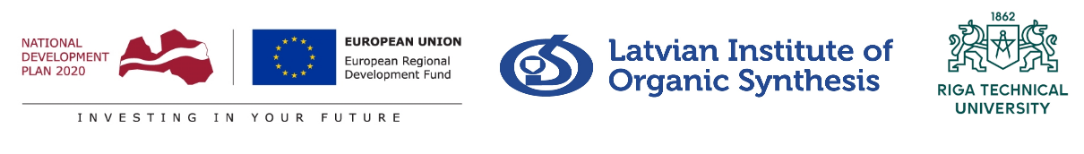
Supported by the European Regional Development Fund “Support for international cooperation projects in research and innovation in Latvian Institute of Organic Synthesis”, contract No. 1.1.1.5/18/I/007

