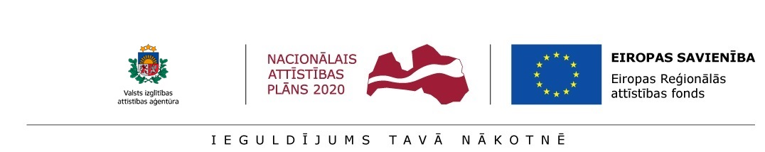

STATEMENT OF THE POST-DOCTORAL RESEARCHER
__. __. _________.
By signing below, I, ________________________, id. No. _______________, hereby confirm that I apply for aid within the frame of Activity 1.1.1.2 “Post-doctoral Research Aid” of the Specific Aid Objective 1.1.1 “To increase the research and innovative capacity of scientific institutions of Latvia and the ability to attract external financing, investing in human resources and infrastructure” of the Operational Programme “Growth and Employment” and:
- I have never before received aid within the frame of the present Activity 1.1.1.2 “Post-doctoral Research Aid” of the Specific Aid Objective 1.1.1 “To increase the research and innovative capacity of scientific institutions of Latvia and the ability to attract external financing, investing in human resources and infrastructure” of the Operational Programme “Growth and Employment”;
- In the event of the allocation of research application aid, I will not concurrently receive remuneration within the frame of the present Activity and within the frame of Activity 1.1.1.1 “Practical Research Aid”, Activity 1.1.1.3 “Innovation Grants to Students” and Activity 1.1.1.5 “Support for International Cooperation Projects in Research and Innovation” of the Specific Aid Objective 1.1.1 “To increase the research and innovative research commissioned by an enterprise, capacity of scientific institutions of Latvia and the ability to attract external financing, investing in human resources and infrastructure” of the Priority Action “Research, Technology Development and Innovations” of the Operational Programme “Growth and Employment”.

__________________
(signature)

